**Model Development Phase**

|  |  |
| --- | --- |
| Date | 5 July 2025 |
| Team ID | SWTID1749620997 |
| Project Title | Online Payment Fraud Detection |
| Maximum Marks | 4 Marks |

**Initial Model Training Code, Model Validation and Evaluation Report**

The initial model training code will be showcased in the future through a screenshot. The model validation and evaluation report will include classification reports, accuracy, and confusion matrices for multiple models, presented through respective screenshots.

**Initial Model Training Code:**

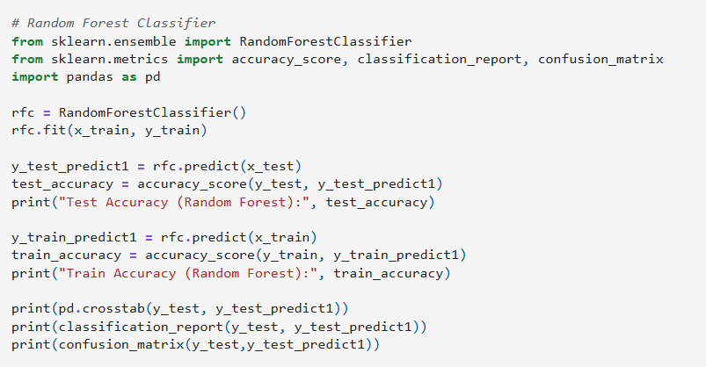

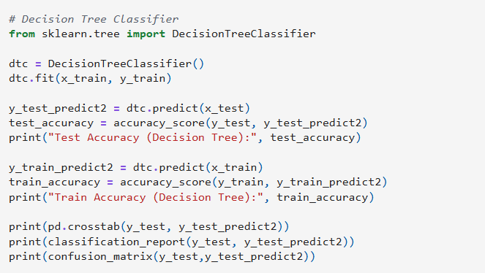

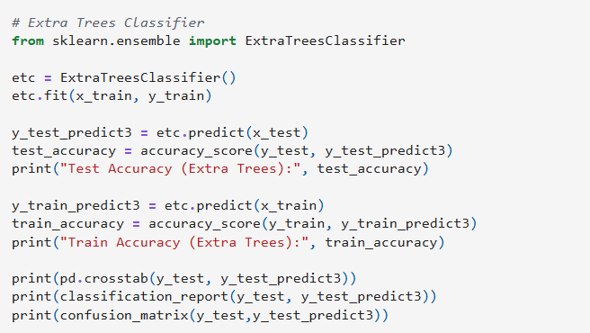

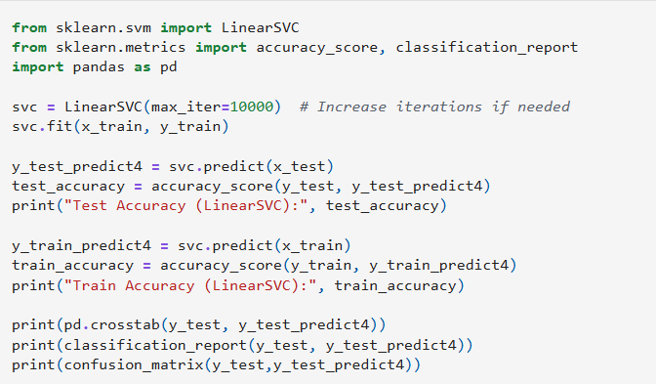

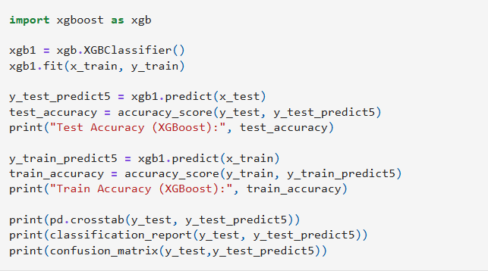

**Model Validation and Evaluation Report:**

|  |  |  |  |
| --- | --- | --- | --- |
| **Model** | **Classification Report** | **Accuracy** | **Confusion Matrix** |
| Random Forest Classifier |  | 0.9997019047708858 |  |
| Decision Tree Classifier |  | 0.9997102870620383 |  |
| Extra Trees Classifier |  | 0.999676757897428 |  |
| Support Vector Machine |  | 0.9976660558071989 |  |
| xgboost Classifier |  | 0.9996940463729302 |  |